Extending HT Condor onto Azure using the GAHP Interface

Azure GAHP Commands

Table of Contents

Executing GAHP 2

Linux 2

Windows 2

GAHP Commands 3

Common Parameters 3

COMMANDS 4

QUIT 4

RESULTS 4

VERSION 5

AZURE_PING 5

AZURE_VM_CREATE 6

AZURE_VM_DELETE 14

AZURE_VM_LIST 18

AZURE_KEYVAULT_CREATE 20

AZURE_VMSS_CREATE 23

Creation of VMSS with GAHP Deletion Job functionality 31

Creation of VMSS with GAHP key vault functionality 34

AZURE_VMSS_DELETE 36

AZURE_VMSS_START 39

AZURE_VMSS_STOP 41

AZURE_VMSS_RESTART 43

AZURE_VMSS_SCALE 44

# Executing GAHP

## Linux

1. Open a Terminal in Linux.
2. Change the present working directory to the GAHP solution directory or to the directory where the GAHP files were saved.



1. Run AzureGAHPServer.py using Python.



## Windows

1. Open a Command prompt in Windows.
2. Change the present working directory to the GAHP solution directory or to the directory where GAHP files were saved.

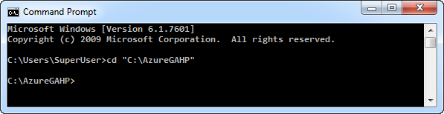

1. Run AzureGAHPServer.py using Python.

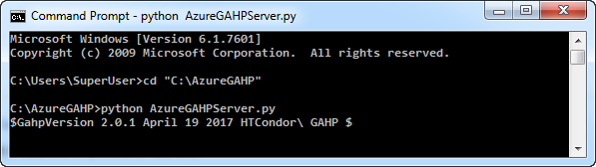

# GAHP Commands

GAHP provide following commands for the various actions on Azure:

* COMMANDS
* VERSION
* AZURE_PING
* QUIT
* RESULTS
* AZURE_VM_CREATE
* AZURE_VM_DELETE
* AZURE_VM_LIST
* AZURE_VMSS_CREATE
* AZURE_VMSS_DELETE
* AZURE_VMSS_START
* AZURE_VMSS_STOP
* AZURE_VMSS_RESTART
* AZURE_VMSS_SCALE

## Common Parameters

Below are the common parameters that need to be included with all the commands except COMMANDS, VERSION, QUIT and RESULTS commands:

* Request Id: *(yellow in below example)*
  + A unique identification number given to a command so that user can differentiate between the results of multiple commands. For example: 1004
* Path of AppSettings.txt: *(green in below example)*
  + The path of the AppSettings.txt file that includes information about the azure subscription credentials, thread configuration and automation job configuration.
* Subscription Id: *(teal in below example)*
  + The Azure subscription id on which GHAP will execute commands.

**Example:**

AZURE_VMSS_CREATE 1004 /home/adminuser/AzureGAHP/AzureGAHP/AppSettings.txt f5a67d06-2d09-4090-91cc-e3298907a021 name=GahpTest location=centralindia size=Standard_D1_v2 image=linux-ubuntu-latest adminUsername=superuser key=Superuser@123 tag=IT customdata=CustomData.txt nodecount=3 --debug

## COMMANDS

Lists all the available commands in the GAHP.

Syntax:

COMMANDS

Example:

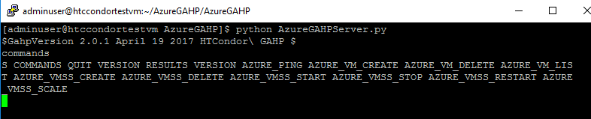

## QUIT

Quits the current running instance of GAHP.

Syntax:

QUIT

Example:

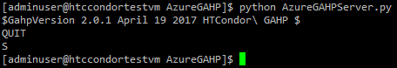

## RESULTS

Shows the results from the previous command(s) executed in current session.

Syntax:

RESULTS

Example:

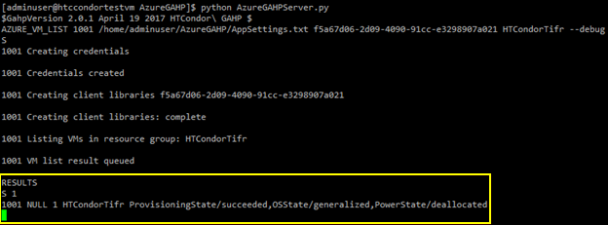

## VERSION

Shows the current version of GAHP.

Syntax:

VERSION

Example:

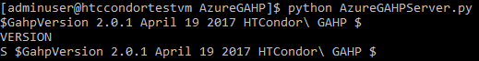

## AZURE_PING

Used to validate the service principal of GAHP. It verifies whether GAHP can access the Azure subscription or not.

Syntax:

AZURE_PING

Example:

AZURE_PING 1001 /home/adminuser/AzureGAHP/AzureGAHP/AppSettings.txt f5a67d06-2d09-4090-91cc-e3298907a021 --debug

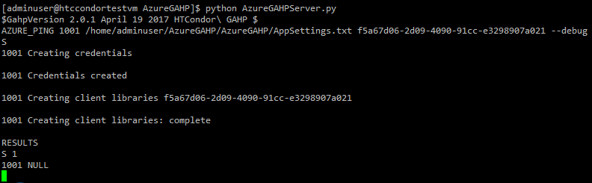

## AZURE_VM_CREATE

1. Creates a VM in a resource group if the resource group is not available then it first creates the resource group.
2. Creates the required artifacts (example – Public IP, Virtual Network, Subnet and NIC) in an Azure subscription based on the options provided with the command.
3. Creates a single VM in a single resource group.

Syntax:

AZURE_VM_CREATE <request id> <path of app_settings.txt> <subscription id> name=<resource group name> location=<location> size=<size> ostype=<windows | linux> image=<image name | vhd url> adminUsername=<username> key=<password | key> tag=<tag value> customdata=<data | file path> datadisks=<diskSize1, diskSize2…> vnetName=<VNet name> vnetRGName=<VNet resource group name> subnetName=<Subnet name> --debug

|  |  |  |  |
| --- | --- | --- | --- |
| **Parameter** | **Value** | **Example** | **Description** |
| Name | *Resource group name* | TestRg0 | Name of the resource group where the VM will be created with  “%*RG name%* + vm” |
| Location | *Location/region* | centralindia | Geographical location/region of the VM and other artifacts |
| Size | *VM size* | Standard_A1 | Size for the Azure VMs. This may differ based on the location. |
| Ostype | *Operating system* | Linux OR windows | Operating system type |
| Image | *Image or vhd uri* | linux-ubuntu-latest  OR  windows-server-latest | Linux /Windows default image or the custom vhd uri |
| adminUsername | *Username* | testuser | Administrator username for login on VM |
| Key | *Admin password or public key* | Testuser@123 | Secure password for the admin username.  Public key is only applicable for Linux OS. |
| Tag | *Tag value* | IT | “Group” is the key for the tag. So for this example tag will be, Group=IT |
| datadisks | *Data disks size in GB* | 50 | Disk size of the VM |
| customdata | *Custom data or data file path* | customdata.txt | Custom data or path of file with custom data that be used while creating VM. |
| vnetName | *Shared Virtual Network name* | TestRgvnet | Name of the Virtual Network where an existing Virtual Network will be shared. The Virtual Network should be in the same region where the VM will be created. |
| vnetRGName | *Resource Group name of the shared Virtual Network* | TestRg | Resource group name of the shared Virtual Network |
| subnetName | *Existing subnet name* | TestRgsubnet | Existing subnet name in the shared Virtual Network |

**Example:**

* Creation of a **Linux** VM with **TestRg0** resource group in **South Central US**, **Basic_A0** size, a username and secure password.

AZURE_VM_CREATE 1001 /home/adminuser/AzureGAHP/AzureGAHP/AppSettings.txt f5a67d06-2d09-4090-91cc-e3298907a021 name=TestRg0 location=southcentralus size=Basic_A0 image=linux-ubuntu-latest adminUsername=adminuser key=Adminuser@123 --debug

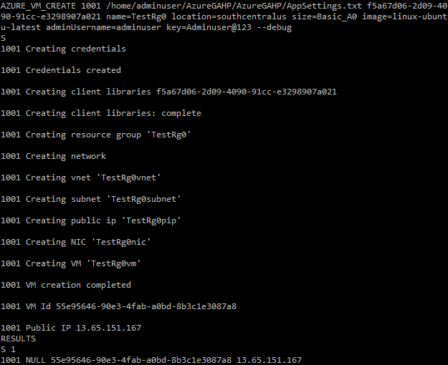

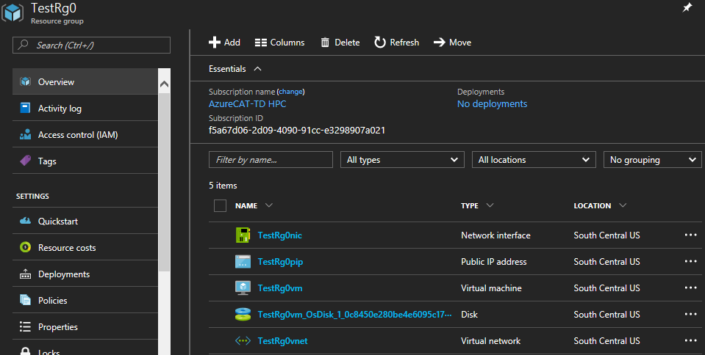

* Creation of a **Linux** VM with **TestRg1** resource group in **Central India**, **Standard_A1** size, a username and **id_rsa.pub** public key.

AZURE_VM_CREATE 1002 /home/adminuser/AzureGAHP/AzureGAHP/AppSettings.txt f5a67d06-2d09-4090-91cc-e3298907a021 name=TestRg1 location=centralindia size=Standard_A1 image=linux-ubuntu-latest adminUsername=adminuser key=/home/adminuser/key/id_rsa.pub --debug

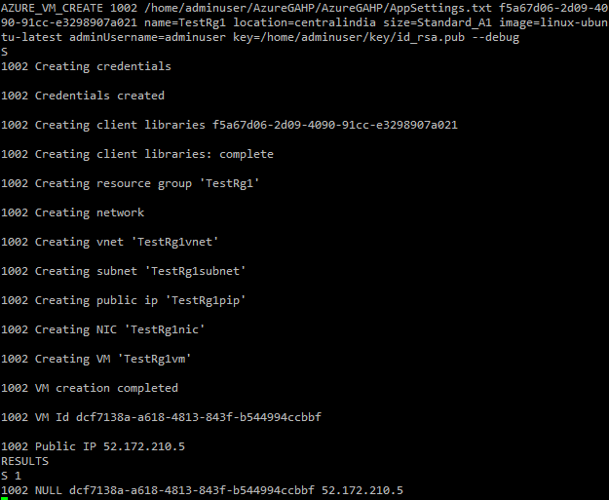

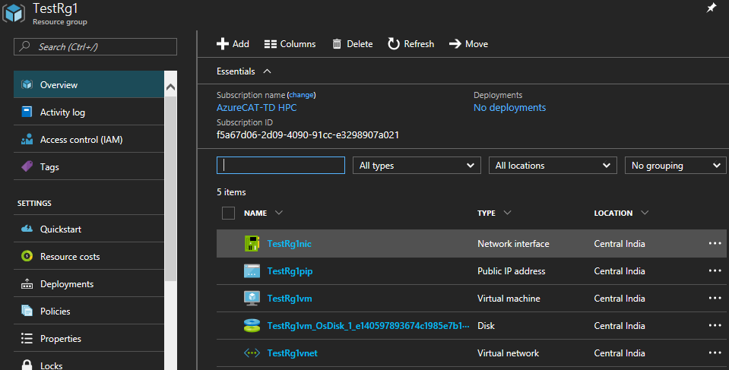

* Creation of a **Windows** VM with **Test1** resource group in **Central India**, **Standard_A1** size, a username and secure password.

AZURE_VM_CREATE 1003 /home/adminuser/AzureGAHP/AzureGAHP/AppSettings.txt f5a67d06-2d09-4090-91cc-e3298907a021 name=Test1 location=centralindia size=Standard_A1 image=windows-server-latest adminUsername=adminuser key=Adminuser@123 --debug

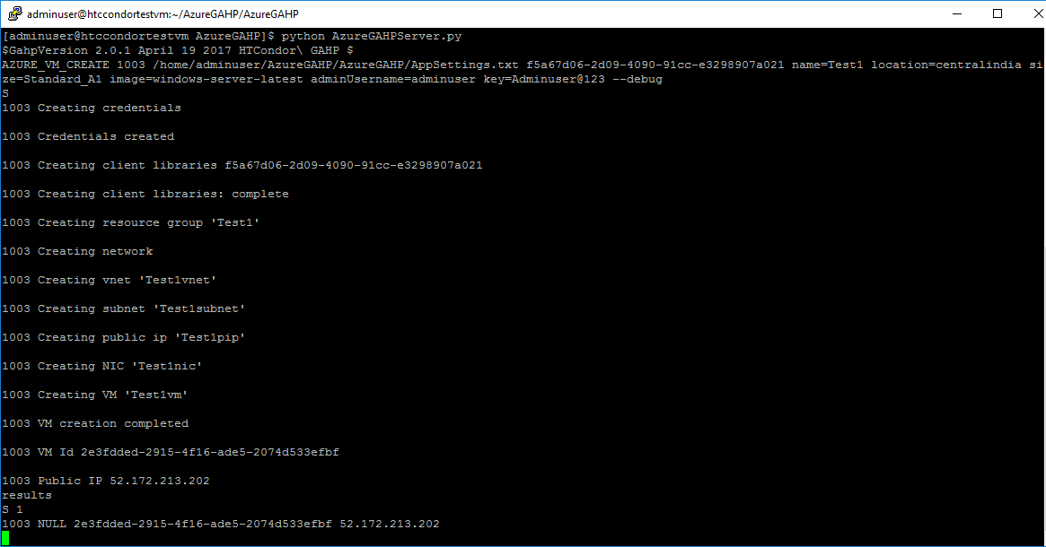

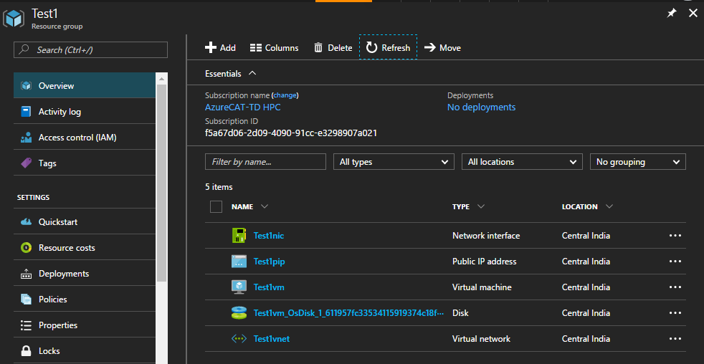

* Creation of a **Linux** VM with **TestRg3** resource group in **South Central US**, **Standard_A1** size, a username and secure password where existing Virtual Network **TestRgvnet** of **TestRg** resource group will shared.

AZURE_VM_CREATE 1004 /home/adminuser/AzureGAHP/AzureGAHP/AppSettings.txt f5a67d06-2d09-4090-91cc-e3298907a021 name=TestRg3 location=southcentralus size=Basic_A0 image=linux-ubuntu-latest adminUsername=adminuser key=Adminuser@123 vnetName=TestRg0vnet vnetRGName=TestRg0 --debug

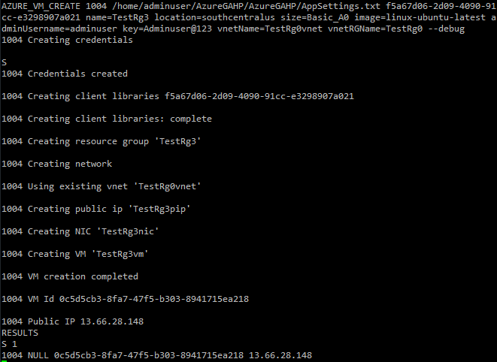

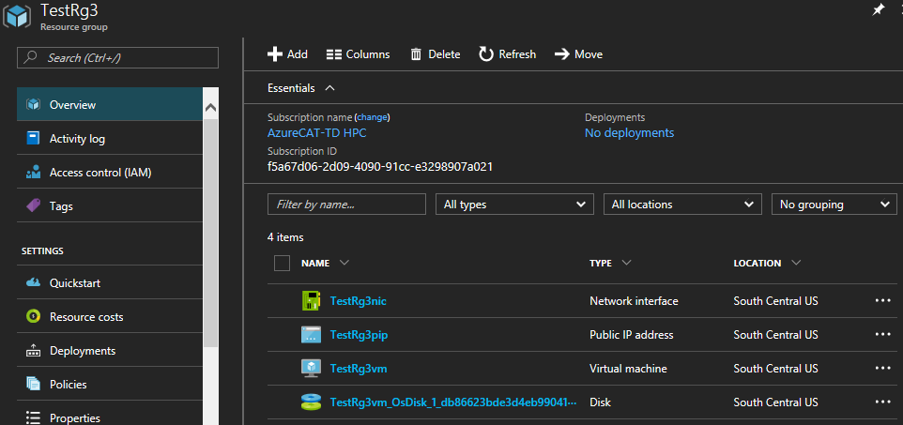

* Creation of a **Linux** VM with **TestRg4** resource group in **Central India**, **Standard_A1** size, a username and secure password using a custom image.

AZURE_VM_CREATE 1005 /home/adminuser/AzureGAHP/AzureGAHP/AppSettings.txt f5a67d06-2d09-4090-91cc-e3298907a021 name=TestVHD location=centralindia size=Basic_A0 adminUsername=adminuser key=Adminuser@123 osType=linux image=https://htcondorwindisks499.blob.core.windows.net/vhds/HTCondorTifrUnVm20170512132246.vhd --debug

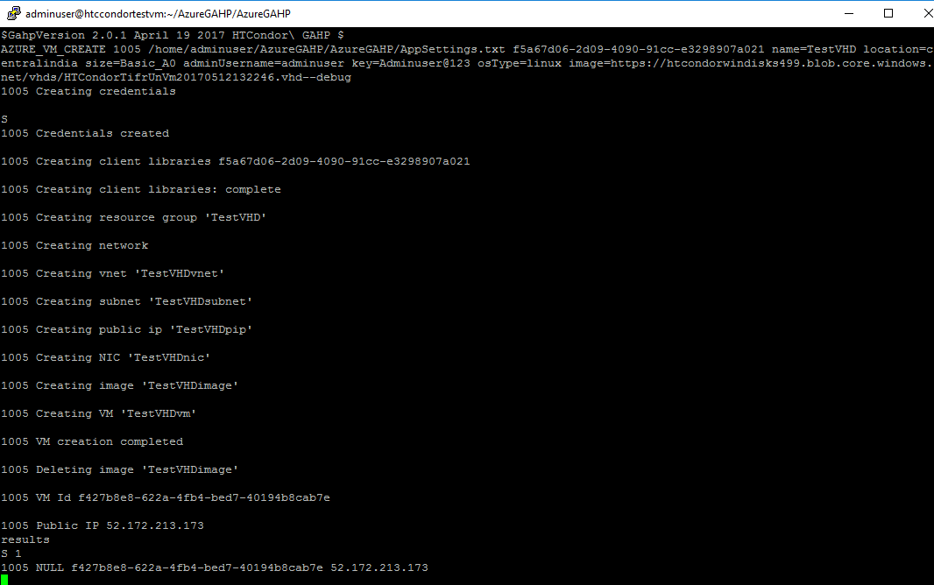

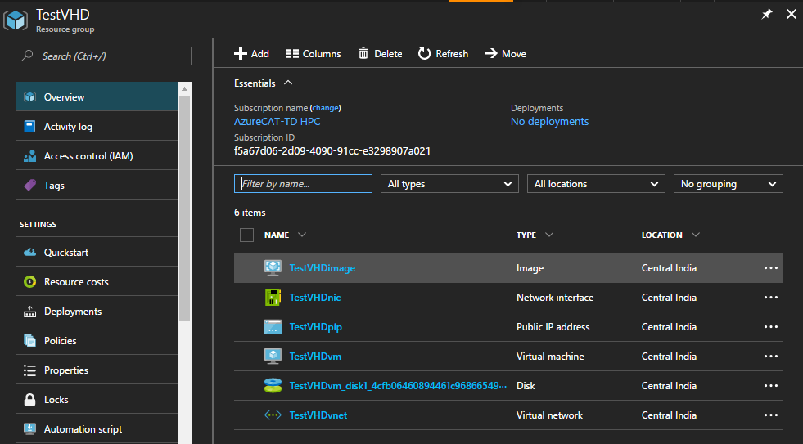

* Creation of a **Linux** VM with **TestRg3** resource group in **South Central US**, **Standard_A1** size, a username and secure password where existing Virtual Network **TestRgvnet** and **TestRgsubnet2** of **TestRg** resource group will be shared.

AZURE_VM_CREATE 1006 /home/adminuser/AzureGAHP/AzureGAHP/AppSettings.txt f5a67d06-2d09-4090-91cc-e3298907a021 name=TestRg6 location=southcentralus size=Basic_A0 image=linux-ubuntu-latest adminUsername=adminuser key=Adminuser@123 vnetRGName=TestRg0 vnetName=TestRg0vnet subnetName=TestRg0subnet2 --debug

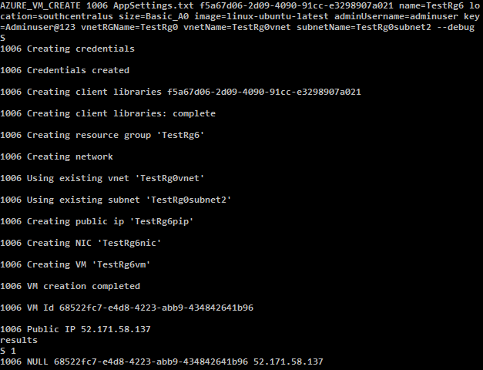

Existing subnets in the **TestRg0vnet** Virtual Network:

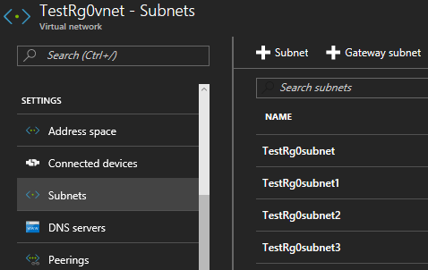

**TestRg6** Resource group with all the created artifacts:

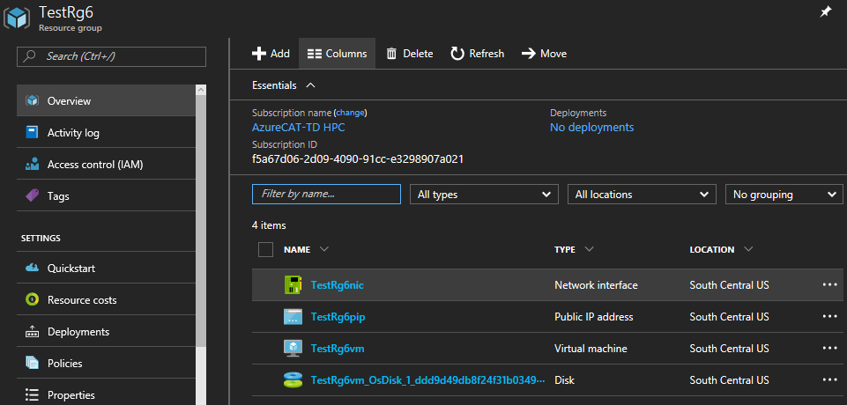

Existing **TestRg0subnet2** subnet is used to share **TestRg0vnet** Virtual Network with **TestRg6nic** nicof **TestRg6vm** VM:

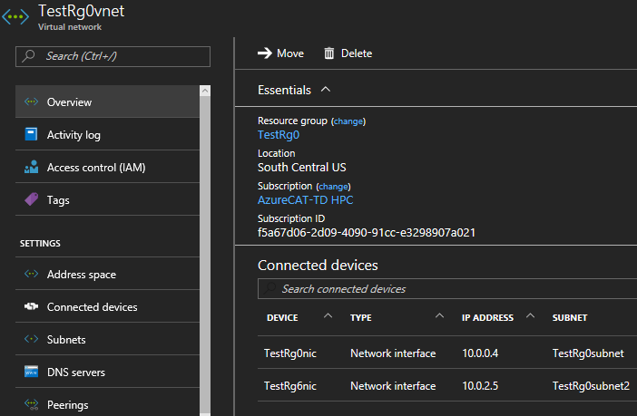

## AZURE_VM_DELETE

Used to delete a resource group, VM and associated artifacts.

Syntax:

AZURE_VM_DELETE <request id> <path of app_settings.txt> <subscription id> <resource group name> <vm name>

|  |  |  |  |
| --- | --- | --- | --- |
| **#** | **Parameter Name** | **Required** | **Description** |
| 1 | Resource group name | Yes | Resource group name |
| 2 | VM name | No | VM name |

Example:

1. Delete VM and associated artifacts by deleting resource group –

AZURE_VM_DELETE 1001 /home/adminuser/AzureGAHP/AzureGAHP/AppSettings.txt f5a67d06-2d09-4090-91cc-e3298907a021 Test

Where “Test” is the resource group name.

Before deleting -

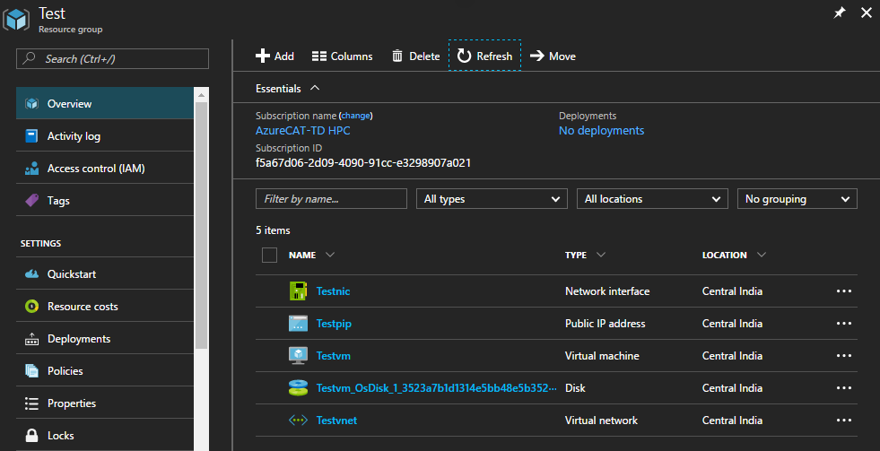

Delete command status -

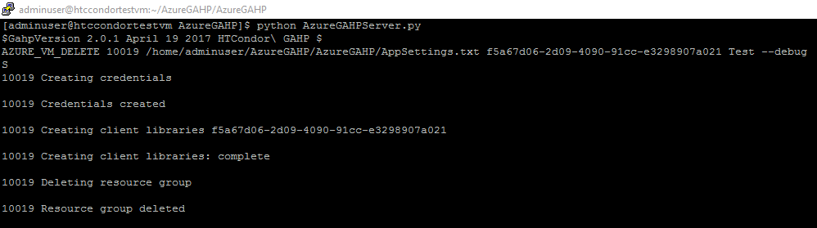

Deleting resource group -

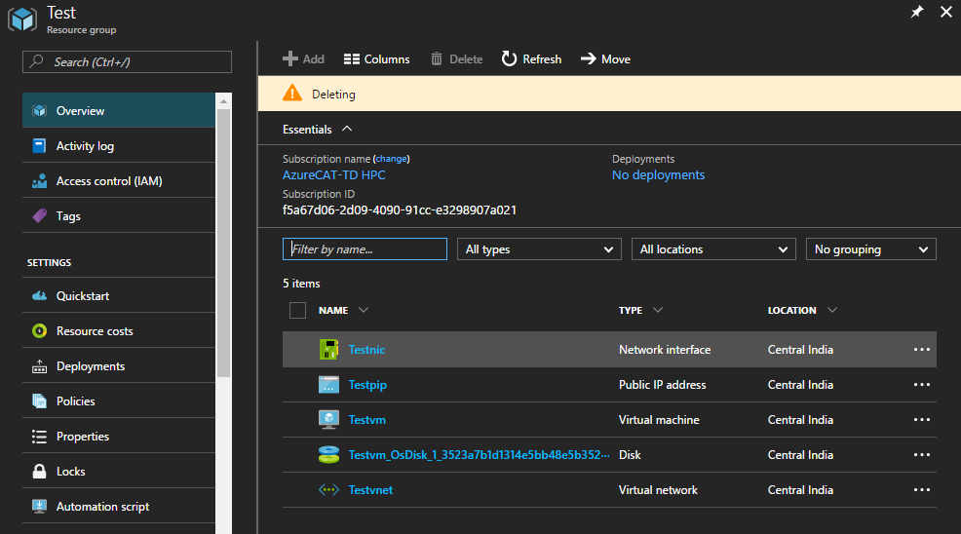

1. Delete VM -

AZURE_VM_DELETE 1002 /home/adminuser/AzureGAHP/AzureGAHP/AppSettings.txt f5a67d06-2d09-4090-91cc-e3298907a021 Test Testvm

Where “Test” is the resource group and “Testvm” VM name.

Before deleting VM –

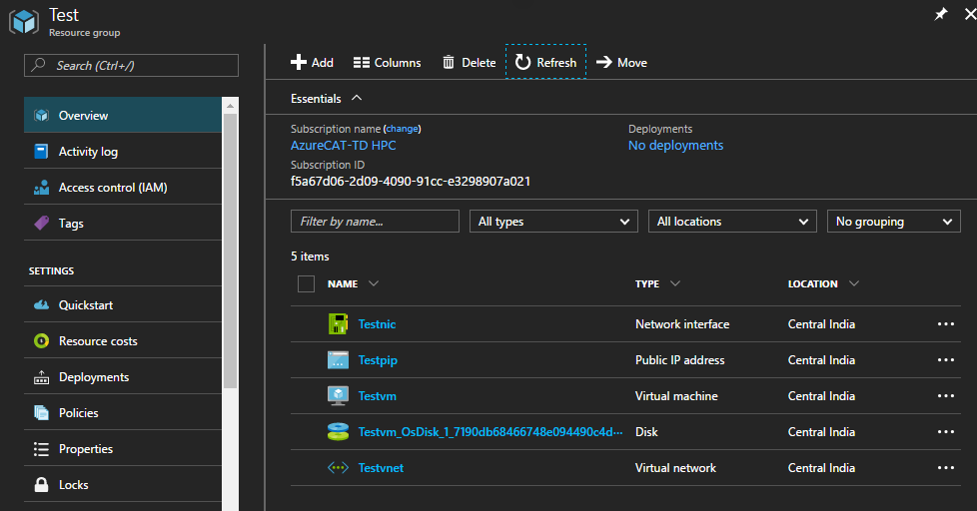

Delete command status –

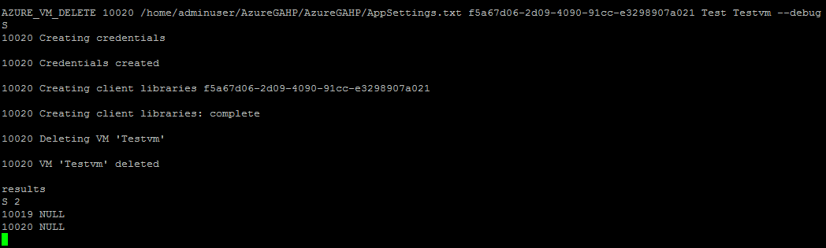

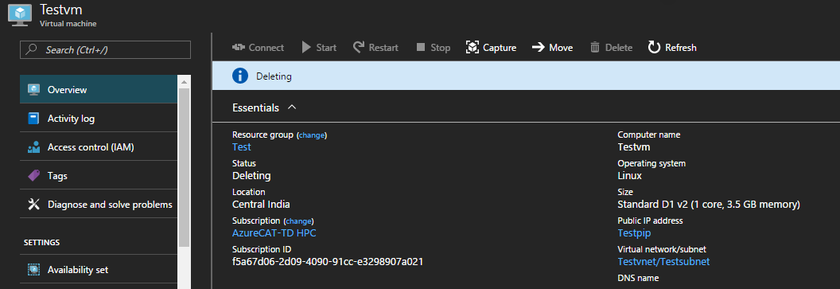

After deleting VM –

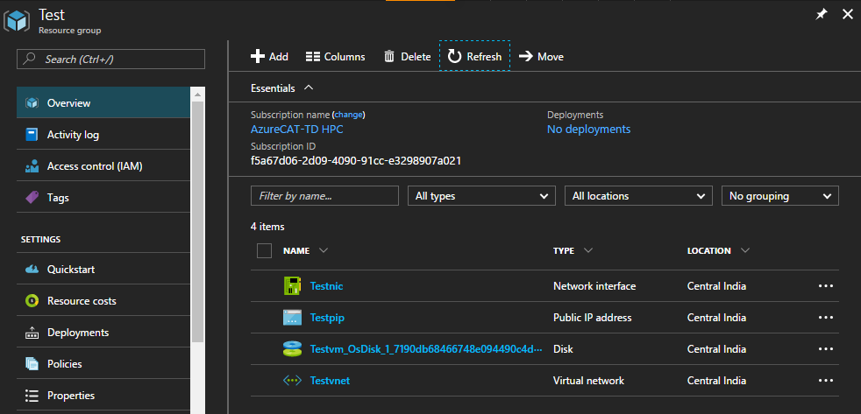

## AZURE_VM_LIST

1. Lists all the VMs by different search options (subscription, resource group and tag).
2. Shows the resource group name of a VM and the VM power state in single line.

Syntax:

AZURE_VM_LIST <request id> <path of app_settings.txt> <subscription id> <resource group name> <vm name> tag=[tag value]

Example:

1. List all the VMs in the subscription -

AZURE_VM_LIST 1001 /home/adminuser/AzureGAHP/AzureGAHP/AppSettings.txt f5a67d06-2d09-4090-91cc-e3298907a021

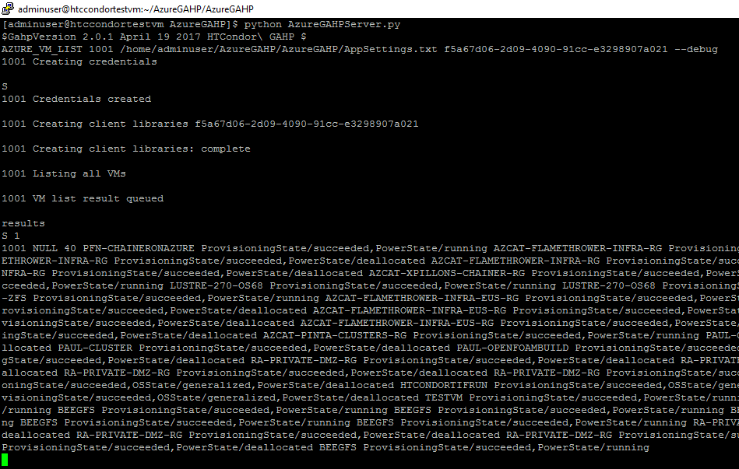

1. List all the VMs in the resource group -

AZURE_VM_LIST 1002 /home/adminuser/AzureGAHP/AzureGAHP/AppSettings.txt f5a67d06-2d09-4090-91cc-e3298907a021 Test

Where “Test” is the resource group name.

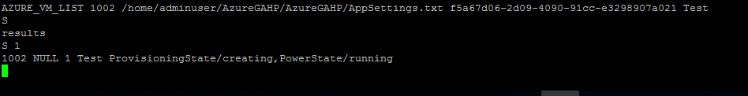

1. List a specific VM -

AZURE_VM_LIST 1003 /home/adminuser/AzureGAHP/AzureGAHP/AppSettings.txt f5a67d06-2d09-4090-91cc-e3298907a021 Test Testvm --debug

Where “Test” is the resource group and “TestVM” is the VM name.

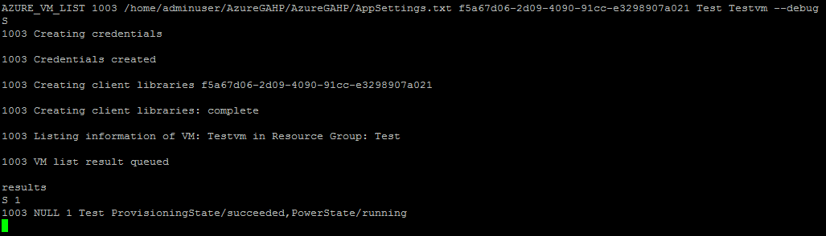

1. List VMs by tag -

AZURE_VM_LIST 1004 /home/adminuser/AzureGAHP/AzureGAHP/AppSettings.txt f5a67d06-2d09-4090-91cc-e3298907a021 tag=IT

Where “IT” value with key “Group”.



## AZURE_KEYVAULT_CREATE

The GAHP server key vault functionality downloads value of a key vault secret in the VMSS node in the post deployment phase.

Using AZURE_KEYVAULT_CREATE command, GAHP user can create or use (if already exists) the required artifacts for this functionality.

Following are pre-requisite to use key vault functionality.

1. An Azure AD group.
2. An Azure key vault.
3. Shell script to download secret in VMSS nodes.

GAHP user needs to provide user ID(s) of the user(s) who will add keys, secrets or certificates from Azure portal. To determine the user ID for a user, in the Azure portal, click the name of the directory and then click the **Users** tab. The **User Name** column lists each user ID.

GAHP user will have to set an Azure AD group name in the AppSettings.txt file. GAHP server will create an Azure key vault with an Azure AD security group, add that AD group and the users (using their user IDs) in the access policies of the key vault. If the Azure AD group already exists, GAHP server will use it for the key vault functionality.

Once the key vault creation is complete, secret can be created from Azure portal by any of the user added in the access policies of the key vault.

Syntax:

AZURE_KEYVAULT_CREATE <request id> <path of app_settings.txt> <subscription id> DeletionJob name=<resource group name> location=<location> sku=<sku> users=<user_id0>,<user_id1> --debug

Parameters:

|  |  |  |  |
| --- | --- | --- | --- |
| **Parameter** | **Value** | **Example** | **Description** |
| Name | *Resource group name* | TestRg | Name of the resource group where key vault will be created with  “%*RG name%* + kv” |
| location | *Location/region* | Centralindia | Geographical location/region of the keyvault |
| sku | *Standard or Premium* | Standard | Pricing tier of the key vault |
| Users | *Object ids of the users separated by comma and no space allowed* | gh4y7d06-2yr6-5048-46gd-e3298907b654, u5a65gh06-1g39-4090-65cc-e3293407a234 | Access policies for users with id <user_id0>, <user_id1> will be added so that they can add keys, secrets or certificates from Azure portal. |

Example:

1. Creation of a **Gahpkv** key vault with **Gahp** resource group in **Central India**, **Standard** sku, a username and secure password.

AZURE_KEYVAULT_CREATE 1001 AppSettings.txt <subscription_id> name=Gahp location=centralindia sku=standard users=<user_id0>, <user_id1> --debug

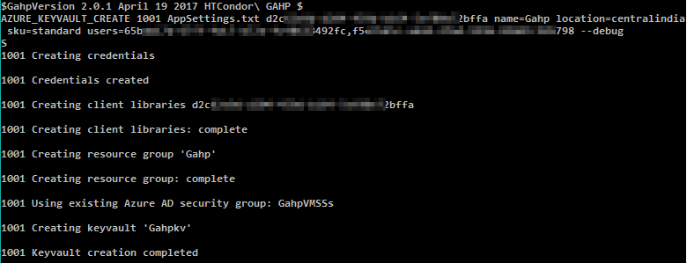

Creation of Gahpkv key vault.

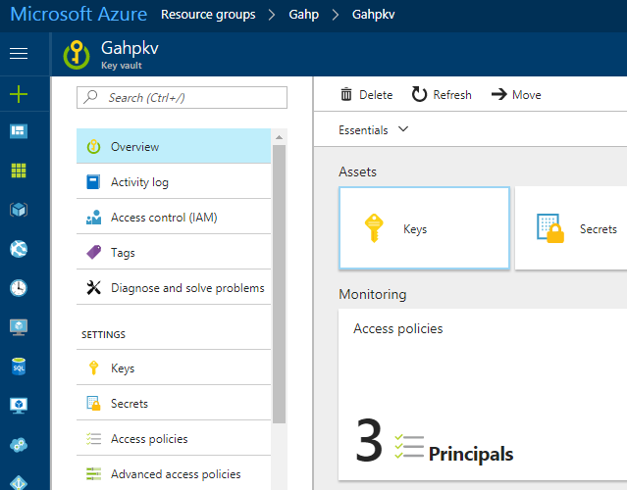

Creation of access policies for users and AD group.

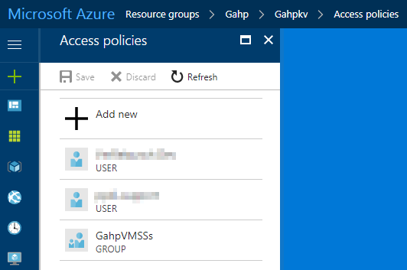

Creation of GahpVMSSs group.

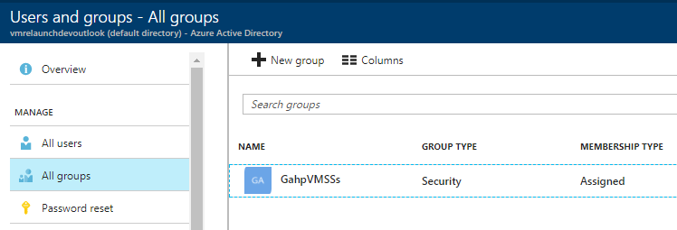

## AZURE_VMSS_CREATE

Create VMSS after creating a resource group in an Azure subscription based on the options provided with the command.

The **DeletionJob** parameter if used can schedule a job in Azure that will delete the resource group at the scheduled time. It will create a scheduler job collection which will have a scheduled job which will execute the PowerShell script to delete the created VMSS at a schedule time. **DeletionJob** parameter requires Azure Automation account to automate the process which can be setup using this section.

Syntax:

AZURE_VMSS_CREATE <request id> <path of app_settings.txt> <subscription id> DeletionJob name=<resource group name> location=<location> size=<size> ostype=<windows | linux> image=<image name | vhd url> adminUsername=<username> key=<password | key> tag=<tag value> customdata=<data | file path> datadisks=<diskSize1, diskSize2…> nodecount=<number of VMs> vnetName=<VNet name> vnetRGName=<VNet resource group name> schedule=<scheduled date and time> keyvaultname=<Azure key vault name> vaultname=<Secret name> --debug

Parameters:

|  |  |  |  |
| --- | --- | --- | --- |
| **Parameter** | **Value** | **Example** | **Description** |
| Name | *Resource group name* | TestRg | Name of the resource group where VM will be created with  “%*RG name%* + vmss” |
| Location | *Location/region* | Centralindia | Geographical location/region of the VM and other artifacts |
| Size | *VM size in the VMSS* | Standard_A1 | Size for the Azure virtual machines in a VMSS. This may differ based on the location. |
| Ostype | *Operating system* | Linux OR windows | Operating system type for VMs in VMSS |
| Image | *Image or vhd uri* | linux-ubuntu-latest  OR  windows-server-latest | Linux / windows default image or the custom vhd uri |
| adminUsername | *Username* | Testuser | Administrator username for login |
| Key | *Admin password or public key* | Testuser@123 | Secure Password for the username for login.  Public key is only applicable for Linux OS. |
| Tag | *Tag value* | IT | “Group” is key of the tag. So, for this example tag will be, Group=IT |
| Datadisks | *Data disks size in GB* | 50 | Disk size of the VMs in VMSS |
| Customdata | *Custom data or data file path* | customdata.txt | Custom data or path of file with custom data which be used while creating VMSS. |
| Nodecount | *Number of VMs* | 25 | Number of VMs to be created in a VMSS. |
| vnetName | *Shared Virtual Network name* | ContosoVnet | Name of the Virtual Network where an existing Virtual Network will be shared. The Virtual Network should be in the same region where the VMSS will be created. |
| vnetRGName | *Resource Group name of the shared Virtual Network* | Contoso | Resource group name of the shared Virtual Network |
| DeletionJob |  |  | *Indicator to register delete job to delete VMSS with a schedule* |
| Schedule | *Job schedule date and time in given format: YYYYMMDDHHmm* | 201706140435 | The date and time at which the scheduled job will start deletion of VMSS. The date and time should in UTC and in the given format i.e. YYYYMMDDHHmm |
| Keyvaultname | *Azure key vault name* | ContosoKeyVault | Name of the Azure key vault where the secret is available |
| Vaultkey | *Secret name* | ContosoSecret | Name of the Secret that is available in the provided Azure key vault |

Example:

1. Creation of a **Linux** VMSS with **Test1** resource group in **South Central US** with **Standard_D1_v2** size, a username and secure password.

AZURE_VMSS_CREATE 1001 /home/adminuser/AzureGAHP/AzureGAHP/AppSettings.txt f5a67d06-2d09-4090-91cc-e3298907a021 name=Test1 location=southcentralus size=Standard_D1_v2 image=linux-ubuntu-latest adminUsername=adminuser key=Adminuser@123 nodecount=3 --debug

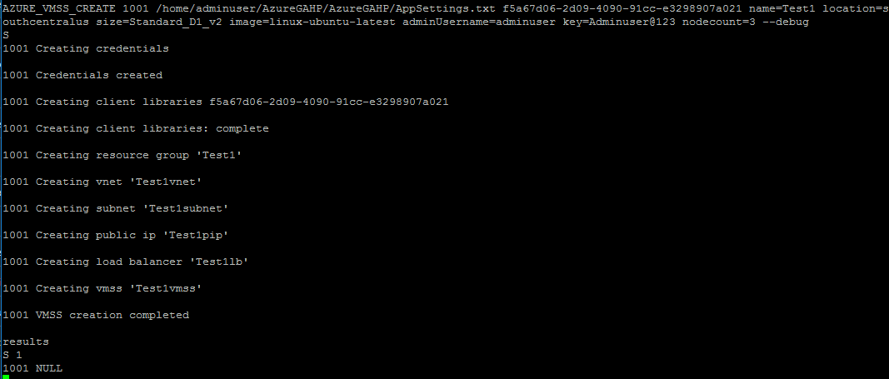

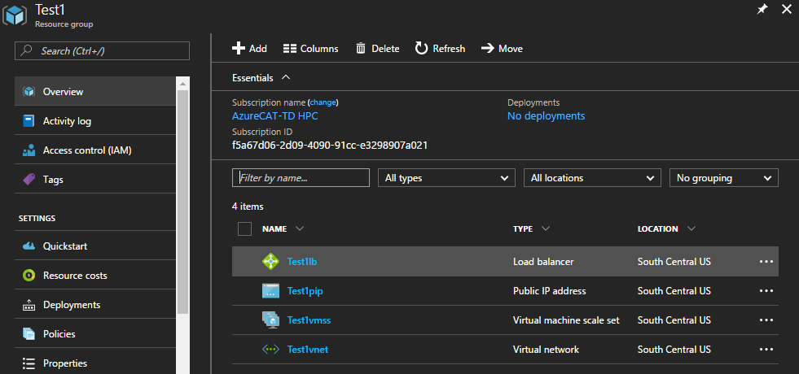

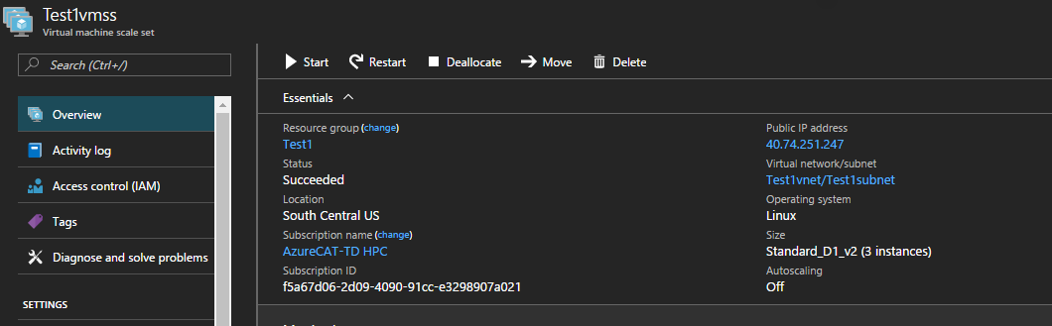

1. Creation of a **Linux** VMSS with **Test2** resource group in **Central India** with **Standard_A1** size, a username and **id_rsa.pub** public key.

AZURE_VMSS_CREATE 1002 /home/adminuser/AzureGAHP/AzureGAHP/AppSettings.txt f5a67d06-2d09-4090-91cc-e3298907a021 name=Test2 location=centralindia size=Standard_A1 image=linux-ubuntu-latest adminUsername=adminuser key=/home/adminuser/.ssh/id_rsa.pub –debug

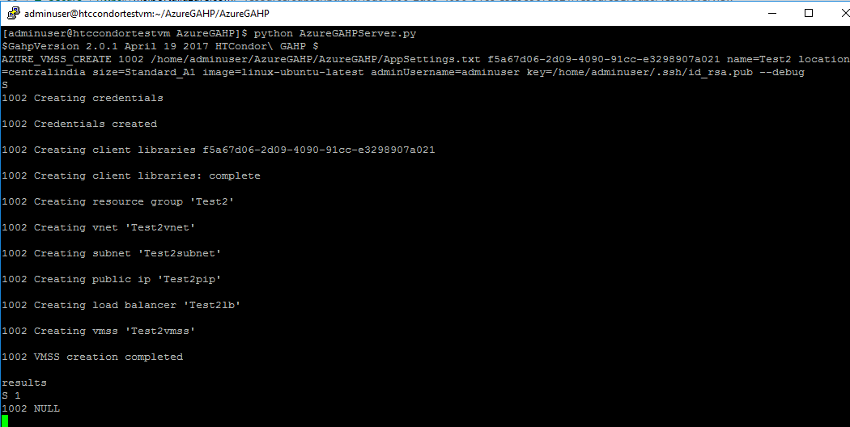

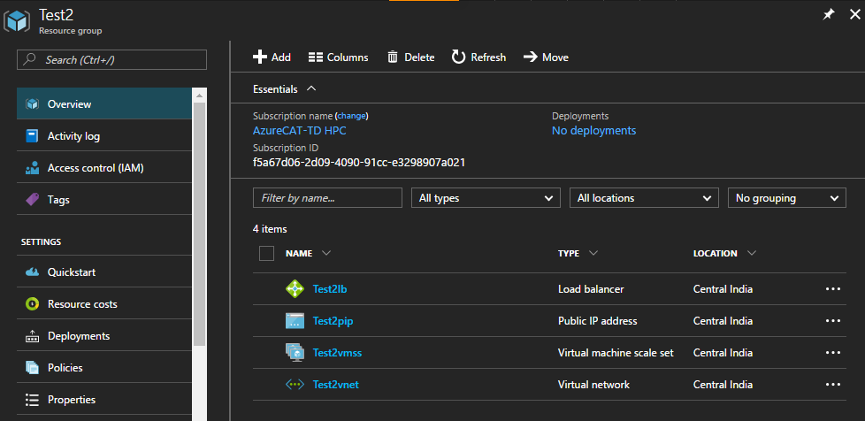

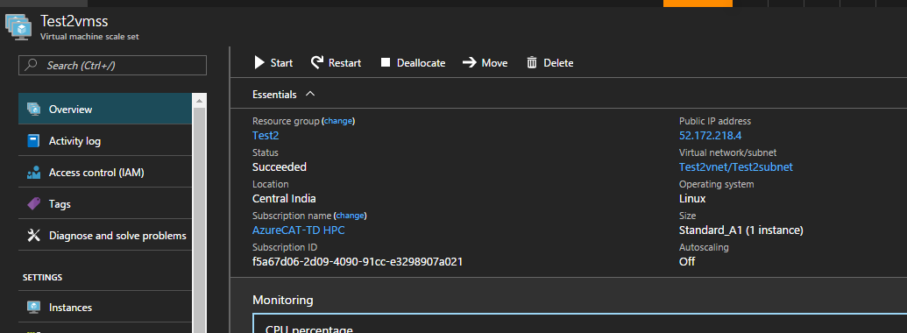

1. Creation of a **Windows** VMSS with **Test3** resource group in **Central India** with **Standard_D1_v2** size, a username and secure password.

AZURE_VMSS_CREATE 1003 /home/adminuser/AzureGAHP/AzureGAHP/AppSettings.txt f5a67d06-2d09-4090-91cc-e3298907a021 name=Test3 location=centralindia size=Standard_D1_v2 image=windows-server-latest adminUsername=adminuser key=Adminuser@123 nodecount=2 –debug

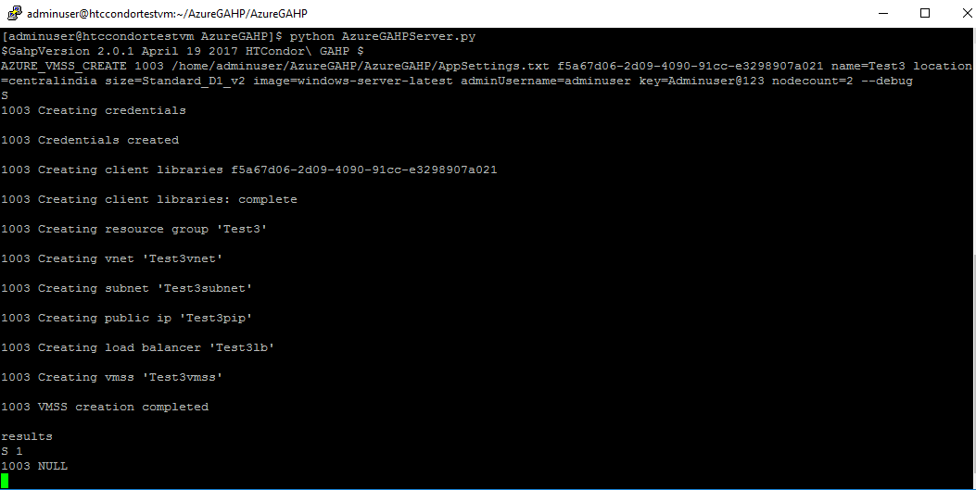

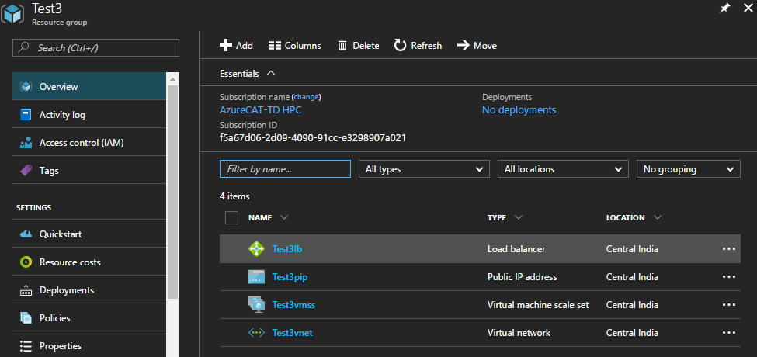

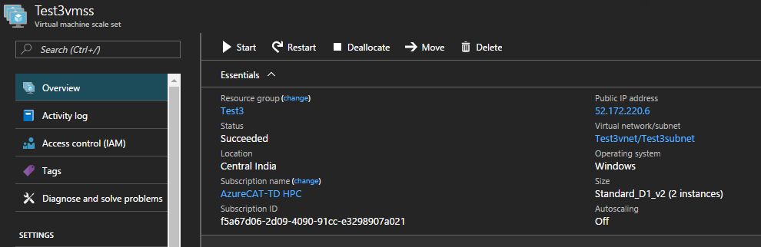

1. Creation of a **Windows** VMSS with **Test4** resource group in **Central India**, **Standard_A1** size, a username and secure password where existing Virtual Network **TestVnet** of **TestRg** resource group will be used.

AZURE_VMSS_CREATE 1004 /home/adminuser/AzureGAHP/AzureGAHP/AppSettings.txt f5a67d06-2d09-4090-91cc-e3298907a021 name=Test4 location=centralindia size=Standard_A1 image=windows-server-latest adminUsername=adminuser key=Adminuser@123 vnetName=TestVnet vnetRGName=TestRg --debug

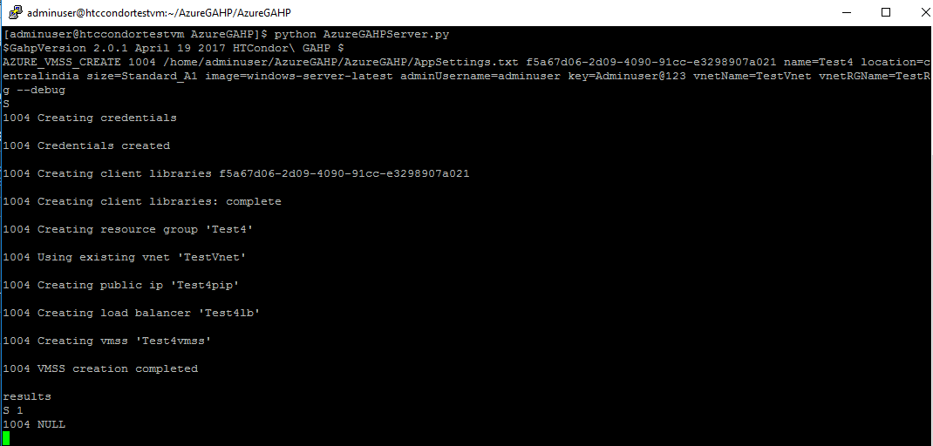

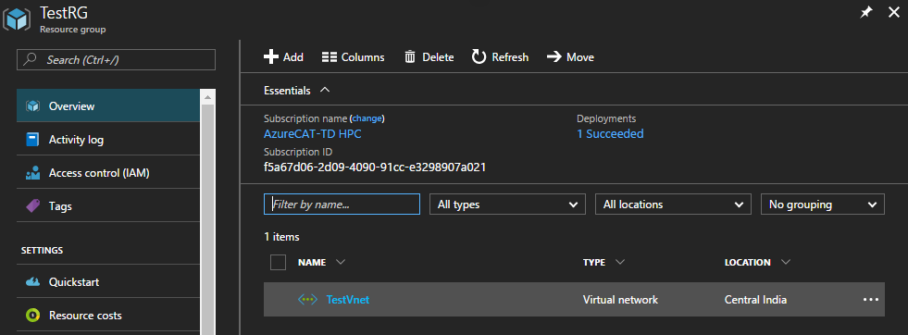

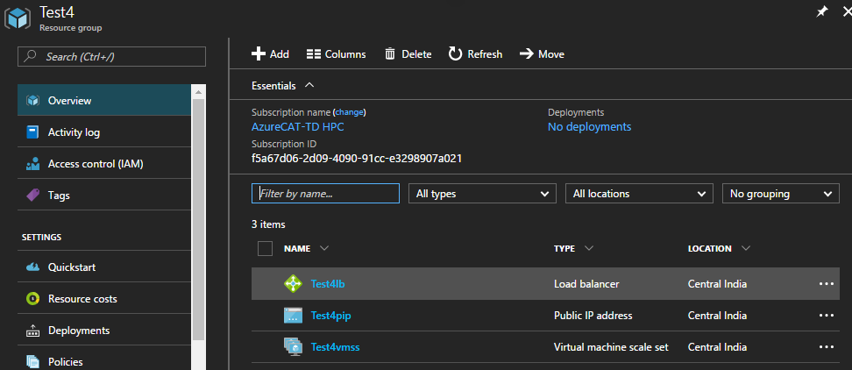

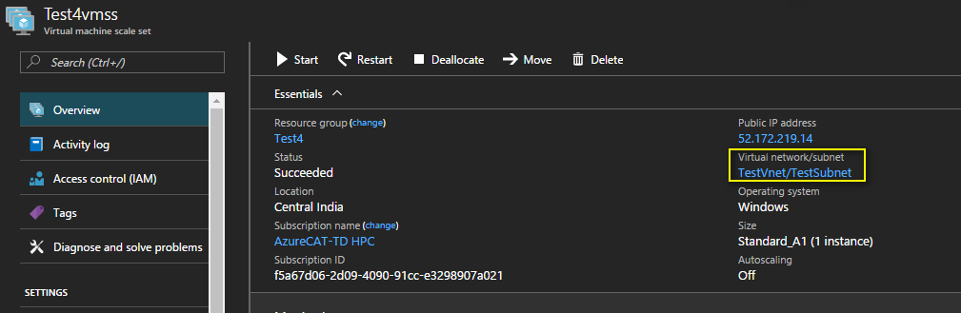

### Creation of VMSS with GAHP Deletion Job functionality

1. Creation of a **Linux** VMSS in **GahpTestRg1** resource group with 2 instances in **Central India**, **Standard_A1** size, a username and secure password. The **DeletionJob** parameter will allow user to schedule a time at which the created VMSS will gets deleted automatically. The scheduled time must be in **UTC** and in **YYYYMMDDHHmm** format.

AZURE_VMSS_CREATE 10013 AppSettings.txt f5a67d06-2d09-4090-91cc-e3298907a021 DeletionJob name=GahpTestRg1 location=centralindia size=Standard_D1_v2 image=linux-ubuntu-latest adminUsername=adminuser key=Adminuser@123 tag=IT nodecount=2 schedule=201706221300 --debug

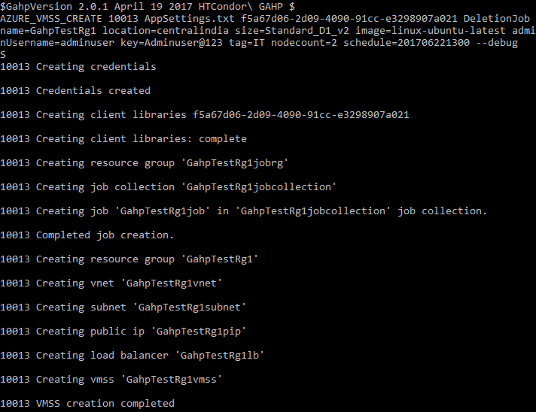

The VMSS and scheduled job got created successfully.

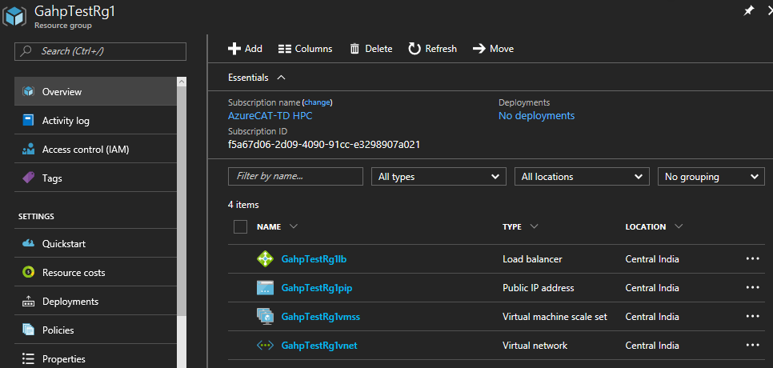

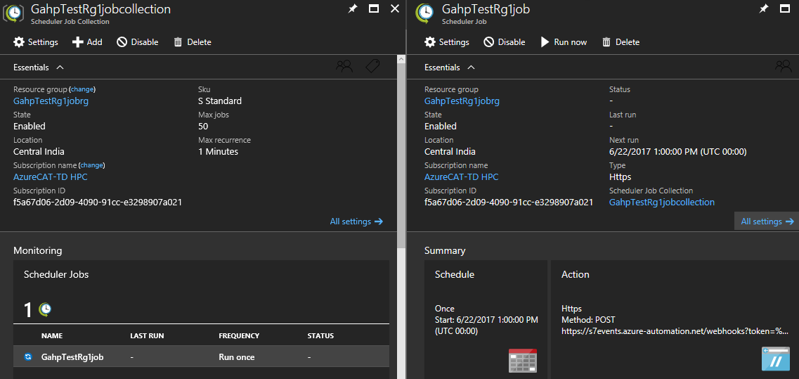

The scheduled job ran successfully.

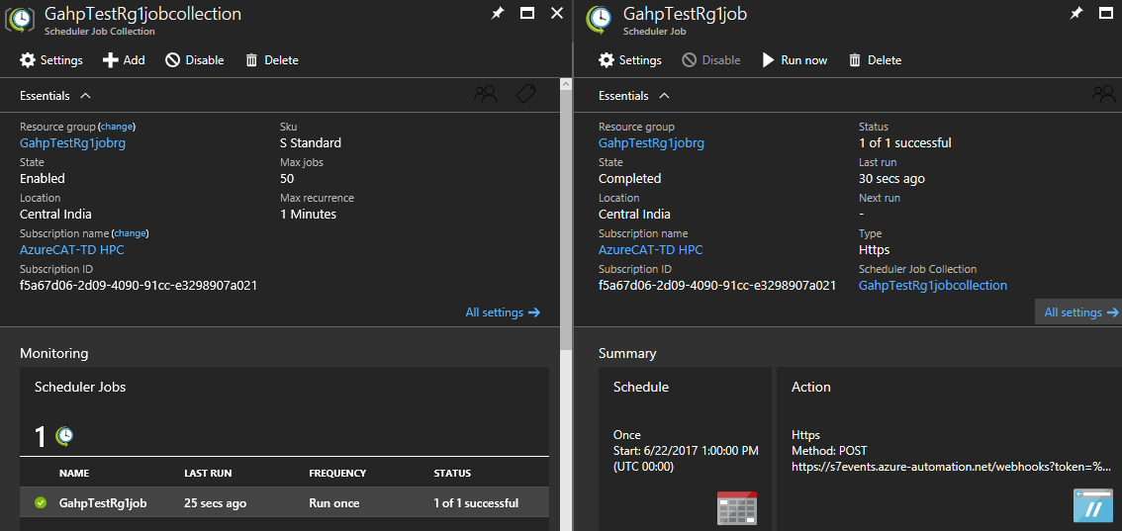

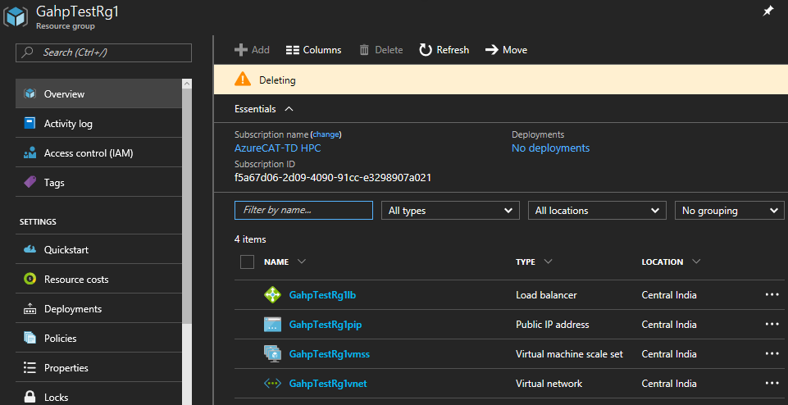

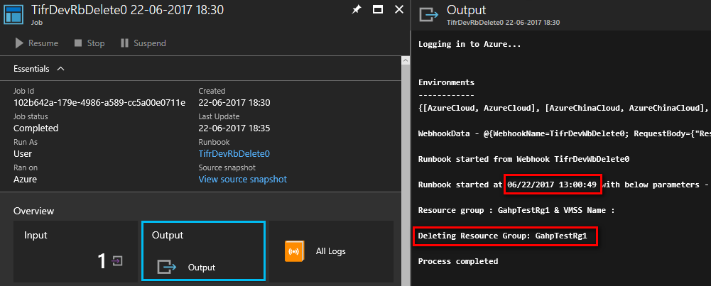

### Creation of VMSS with GAHP key vault functionality

GAHP key vault functionality allows user to download the latest value of secret from an Azure key vault in the VMSS nodes of the VMSS created using AZURE_VMSS_CREATE command.User need to provide information about Azure key vault and secret with AZURE_VMSS_CREATE command which is Azure key vault name and secret name.

In the post deployment phase VMSS will download the latest secret value in a file using Linux MSI extension and a custom shell script in a folder in root directory. The name of the file and the folder will be same as the secret name and Azure key vault name, respectively.

The instructions to setup GAHP for this functionality are provided in this section.

For example: if **GahpKv** is Azure key vault name and **GahpSecret** is secret name then the secret value will be downloaded in **/root/GahpKv/GahpSecret** file.

1. Creation of a **Linux** VMSS in **Gahp** resource group with 3 instances in **Central India, Standard_A1** size, a username and secure password. The value of **gahpsecret** secret from **gahpkv** Azure key vault will be download in the **/root/gahpkv/gahpsecret** file.

AZURE_VMSS_CREATE 10013 AppSettings.txt <subscription_id> name=Gahp location=centralindia size=Standard_A1 image=linux-ubuntu-latest adminUsername=adminuser key=Adminuser@123 tag=IT nodecount=3 keyvaultrg=Gahp keyvaultname=gahpkv vaultkey=gahpsecret --debug

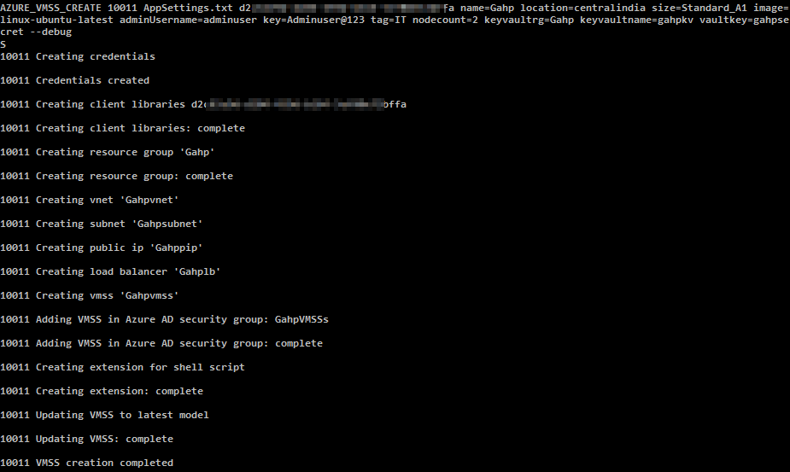

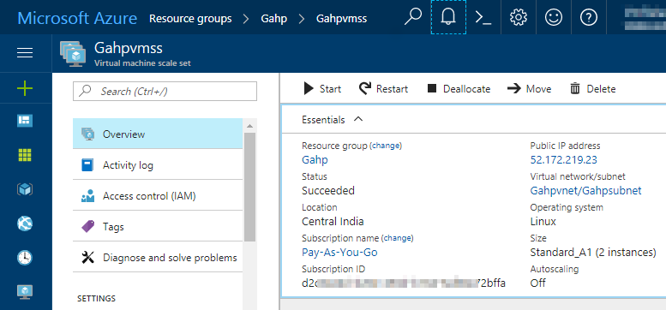

Azure Key vault and secret which will be downloaded on VM. Highlighted is the secret value.

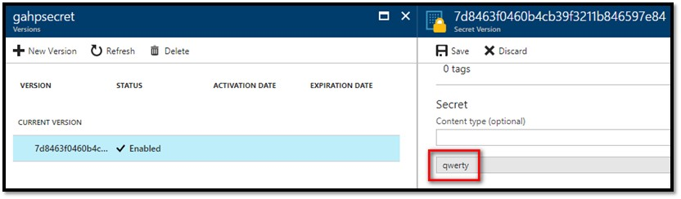

Verify the downloaded secret from Azure key vault.

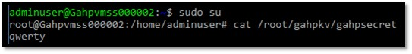

## AZURE_VMSS_DELETE

1. Used to delete a VMSS.
2. Used to delete the resource group and VMSS.

Syntax:

AZURE_VMSS_DELETE <request id> <path of app_settings.txt> <subscription id> <resource group name> <vmss name>

|  |  |  |  |
| --- | --- | --- | --- |
| **#** | **Parameter Name** | **Required** | **Description** |
| 1 | Resource group name | Yes | Resource group name |
| 2 | VM name | No | VMSS name |

Example:

1. Delete a resource group to delete VMSS and associated artifacts.

AZURE_VMSS_DELETE 1001 /home/adminuser/AzureGAHP/AzureGAHP/AppSettings.txt f5a67d06-2d09-4090-91cc-e3298907a021 Test

Where “Test” is the resource group name.

Before deleting VMSS –

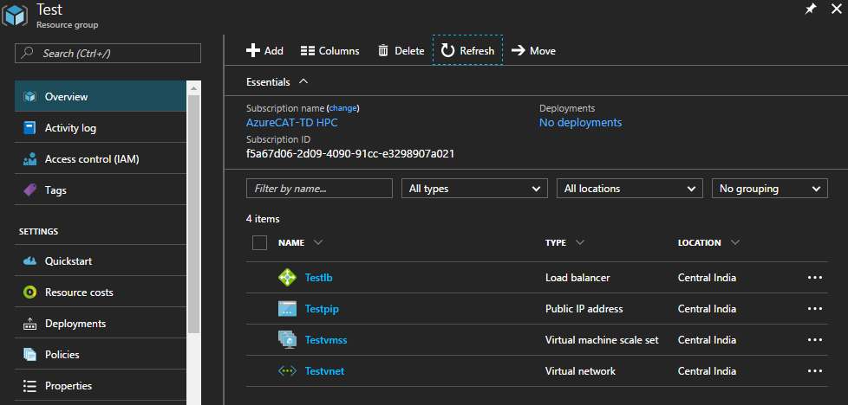

Delete resource group command status –

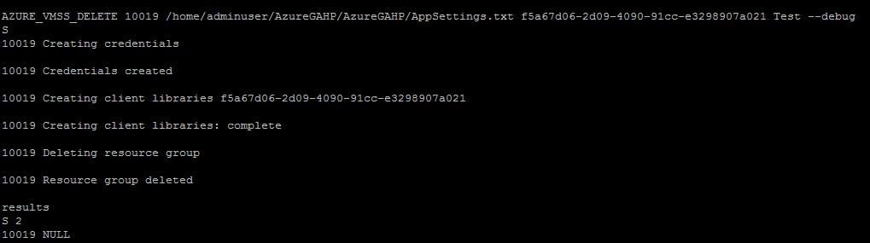

1. Delete VMSS -

AZURE_VMSS_DELETE 1002 /home/adminuser/AzureGAHP/AzureGAHP/AppSettings.txt f5a67d06-2d09-4090-91cc-e3298907a021 Test Testvmss

Where “Test” is the resource group name and “Testvmss” is the VMSS name.

Before deleting VMSS –



Delete VMSS command status –

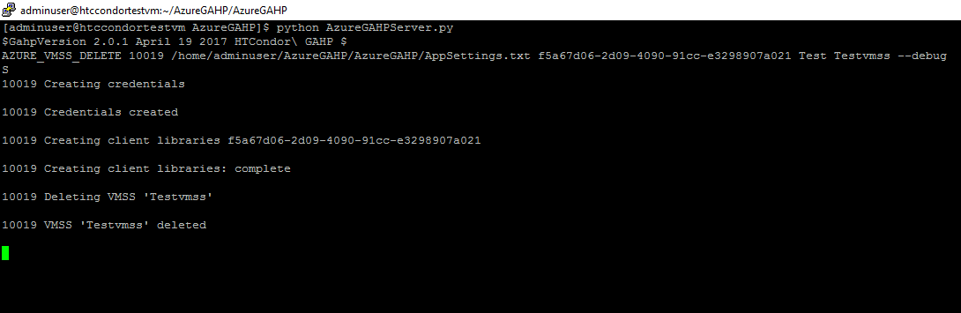

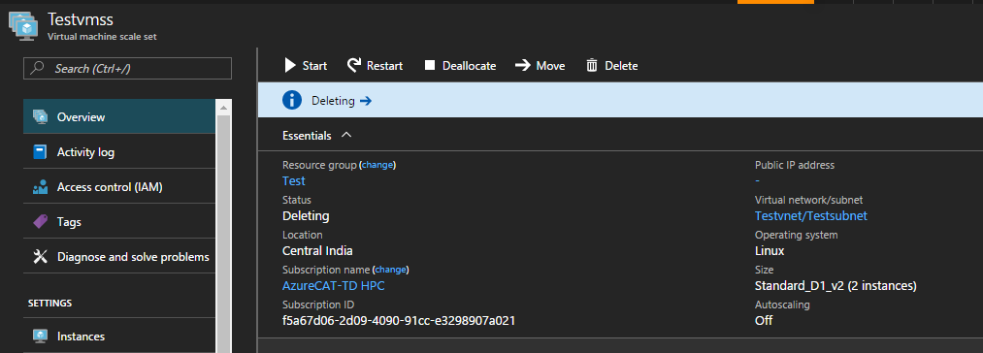

After deleting VMSS –

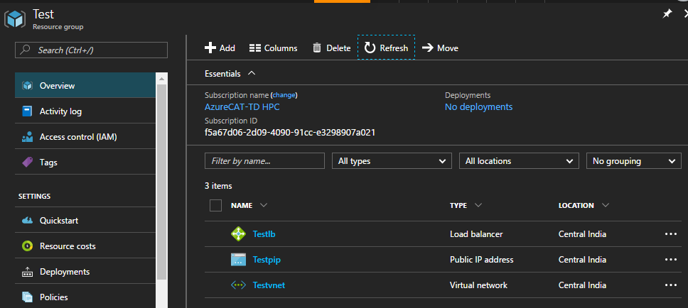

## AZURE_VMSS_START

Used to start all the VMs in a virtual machine scale set.

Syntax:

AZURE_VMSS_START <request id> <path of app_settings.txt> <subscription id> <resource group name> <vmss name>

Example:

AZURE_VMSS_START 1001 /home/adminuser/AzureGAHP/AzureGAHP/AppSettings.txt f5a67d06-2d09-4090-91cc-e3298907a021 Test Testvmss

Where “Test” is the resource group and “Testvmss” is the virtual machine scale set.

Before starting:

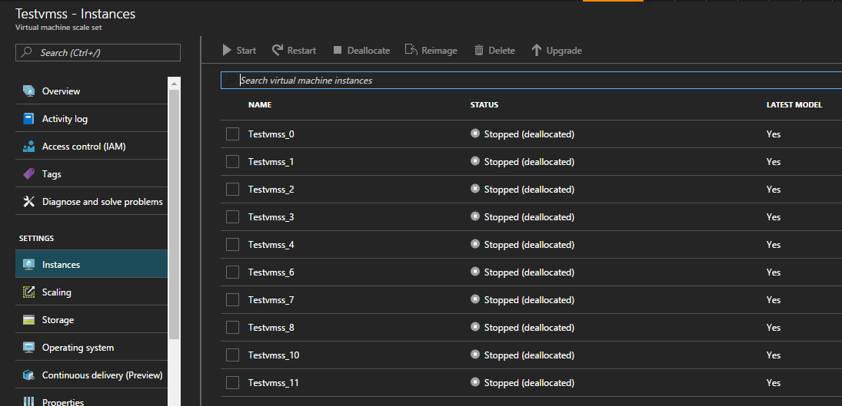

VMSS start command status –

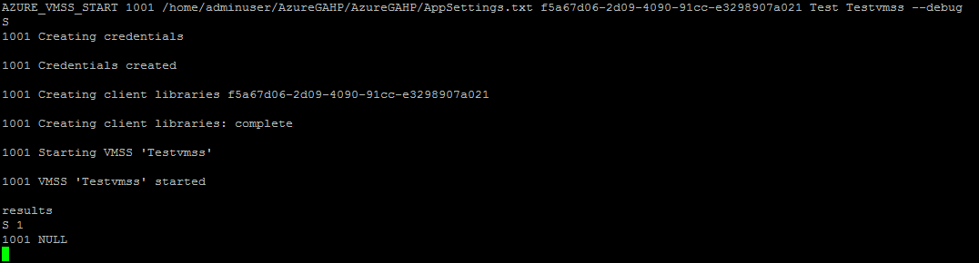

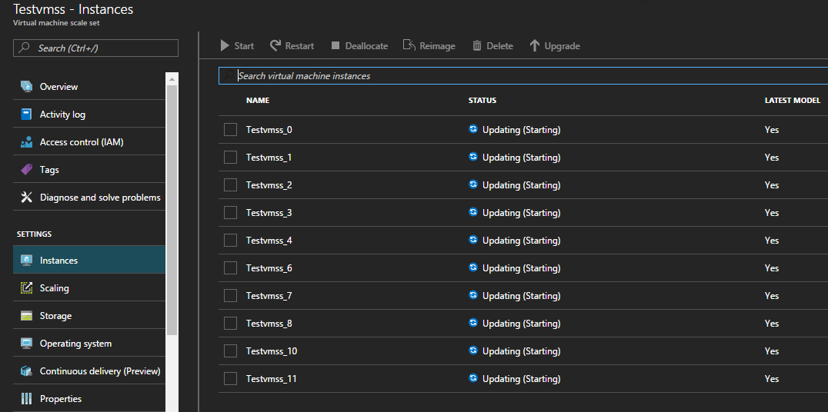

After starting VMSS –

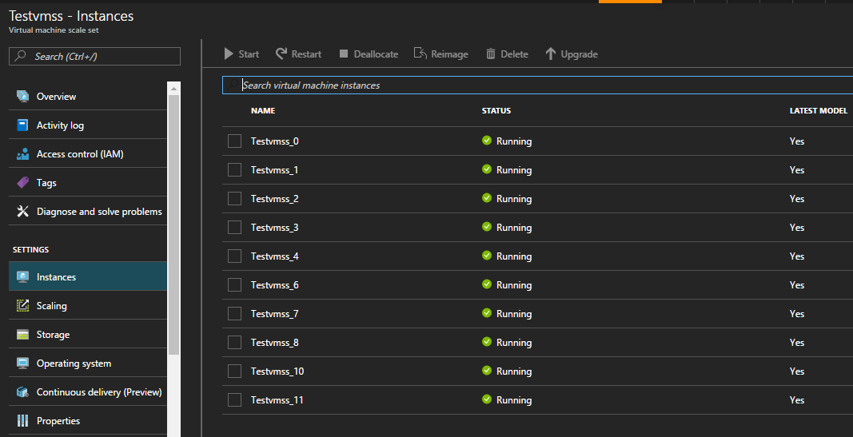

## AZURE_VMSS_STOP

Used to stop all the virtual machine(s) in a virtual machine scale set.

Syntax:

AZURE_VMSS_STOP <request id> <path of app_settings.txt> <subscription id> <resource group name> <vmss name>

Example:

AZURE_VMSS_STOP 1001 /home/adminuser/AzureGAHP/AzureGAHP/AppSettings.txt f5a67d06-2d09-4090-91cc-e3298907a021 Test Testvmss

Where “Test” is the resource group and “Testvmss” is the virtual machine scale set.

Before stopping –



VMSS start command status –

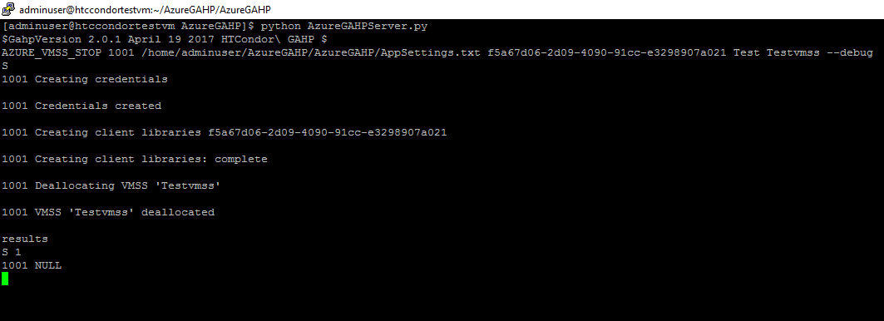

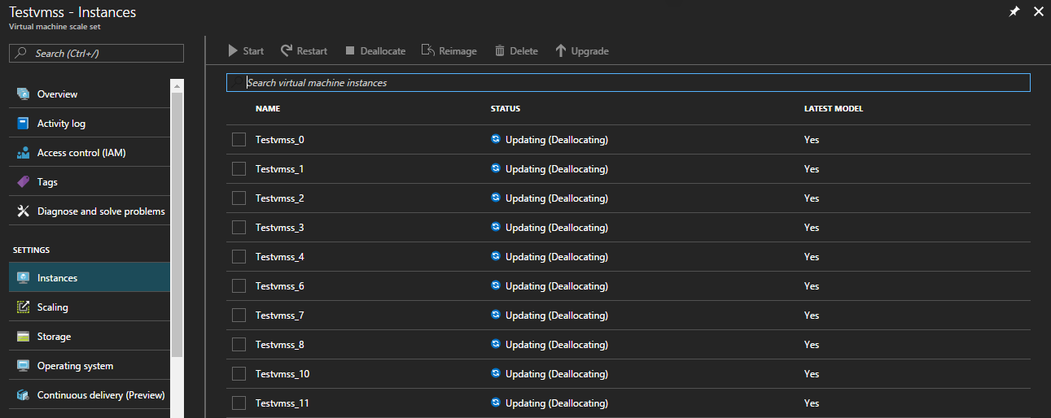

After stopping VMSS –



## AZURE_VMSS_RESTART

Used to restart all the VMs in a virtual machine scale set.

Syntax:

AZURE_VMSS_STOP <request id> <path of app_settings.txt> <subscription id> <resource group name> <vmss name>

Example:

AZURE_VMSS_RESTART 1001 /home/adminuser/AzureGAHP/AzureGAHP/AppSettings.txt f5a67d06-2d09-4090-91cc-e3298907a021 Test Testvmss --debug

Where “Test” is the resource group and “Testvmss” is the virtual machine scale set.

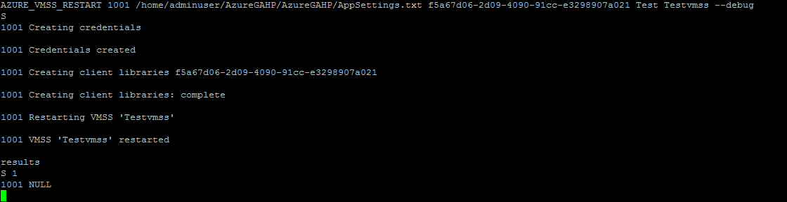

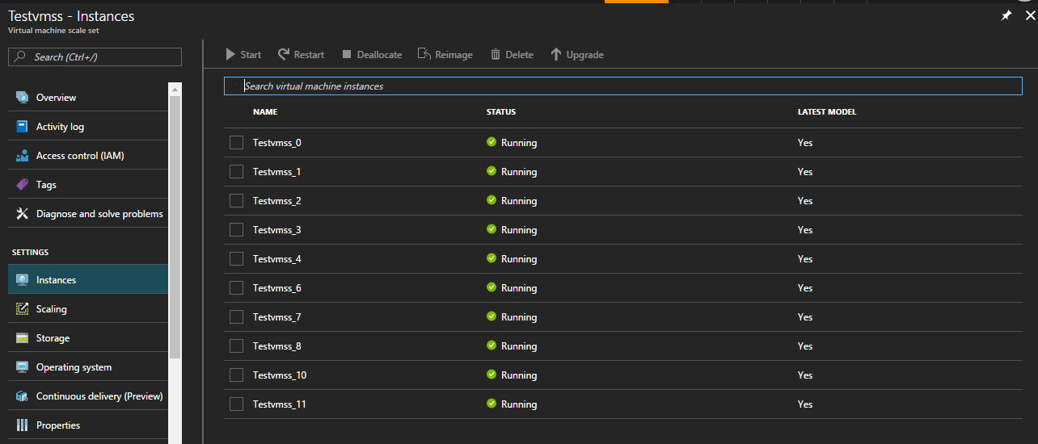

## AZURE_VMSS_SCALE

Used to scale up/down the VMSS instances.

Syntax:

AZURE_VMSS_SCALE <request id> <path of app_settings.txt> <subscription id> <resource group name> <vmss name> <instance count>

Example:

AZURE_VMSS_SCALE 1001 /home/adminuser/AzureGAHP/AzureGAHP/AppSettings.txt f5a67d06-2d09-4090-91cc-e3298907a021 Test1 Test1vmss 7 --debug

Where “Test1” is the resource group, “Test1vmss” is the VMSS and 7 is the instance count which will be updated.

Existing VMSS with 3 instances -

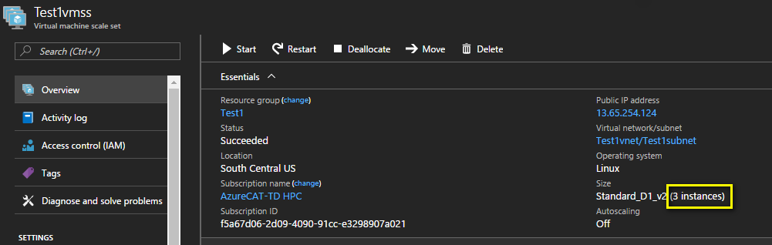

Command started scaling the instances -

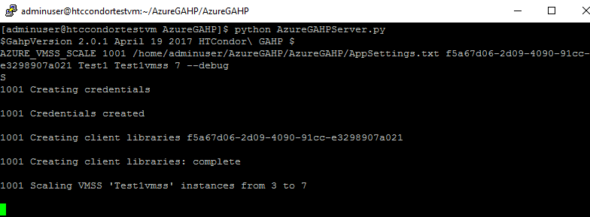

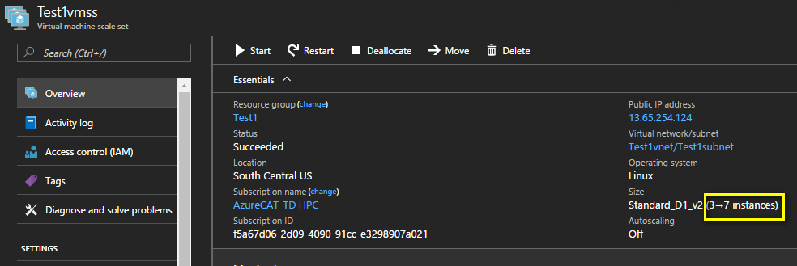

Command completed –

